Objective Questions:

1.What is the total no. of tables present in the data?
Ans. there are 2 tables in this sheet
I.Raw data
II..country description

2.What is the total no. of attributes present in the data?
Ans.The Raw Data sheet contains a total of 20 attributes

3.How many categorical columns are there in the data? [Search about categorical and continuous data, and try to answer this question]

Ans. The sheet contains a total of 12 categorical columns.
RestaurantName ,CountryName , City, Address ,locality,localityverbose,cuisines, currency ,Has_table_booking , Has_online_delivery,is_deliverying_now , swich_to_order_menu,

4.The data consists of some inconsistent and missing values so ensure that the data used for further analysis is cleaned.
Ans.

· To find out the missing data or some inconsistent value I have used ctrl+g function to find missing value
· after analysis i fineded 9 missing value
· The data which is lost is the cuisine data where many cuisine where missing
· Then I created a new column . column name updated cuisines
. Then I fill in all missing values . i used upper value of the data to fill the missing value
. the value show in raw data sheet column L

5.Using the LookUp functions, fill up the countries in the original data using the country code.
Ans.Created new column name country .
=VLOOKUP(C2,'country description'!A:B,2) and then use fill handle

6.Create a table to represent the number of restaurants opened in each country.

country | COUNTA of RestaurantName
Australia | 24
Brazil | 60
Canada | 4
India | 8652
Indonesia | 21
New Zealand | 40
Philippines | 22
Qatar | 20
Singapore | 20
South Africa | 60
Sri Lanka | 20
Turkey | 34
United Arab Emirates | 60
United Kingdom | 80
United States of America | 434
Grand Total | 9551

Ans. select all then go to insert create pivot table country in row and restaurant name in values and apply counta in value section.

7.Also, the management wants to look at the number of restaurants opened each year, so provide them with something here.

Ans.first of all i create a new column name Year select all then go to insert create pivot table year in row and restaurant name in values and apply counta in value.

year | COUNTA of RestaurantID
2010 | 1080
2011 | 1098
2012 | 1022
2013 | 1061
2014 | 1051
2015 | 1024
2016 | 1027
2017 | 1086
2018 | 1102
Grand Total | 9551

8.What is the total number of restaurants in India in the price range of 4?

Ans.388 ( process- select all then go to insert create pivot table country in rows and restaurant name in values and apply count in value section.and then also take filter in county select india )
country | COUNTA of RestaurantID
Australia | 1
Brazil | 35
Canada | 1
India | 388
New Zealand | 16
Philippines | 9
Qatar | 14
Singapore | 14
South Africa | 39
Sri Lanka | 3
Turkey | 5
United Arab Emirates | 22
United Kingdom | 16
United States of America | 23
Grand Total | 586

9.What is the average number of voters for the restaurants in each country according to the data?

country | AVERAGE of Votes
Australia | 111.4166667
Brazil | 19.61666667
Canada | 103
India | 137.212552
Indonesia | 772.0952381
New Zealand | 243.025
Philippines | 407.4090909
Qatar | 163.8
Singapore | 31.9
South Africa | 315.1666667
Sri Lanka | 146.45
Turkey | 431.4705882
United Arab Emirates | 493.5166667
United Kingdom | 205.4875
United States of America | 428.2211982
Grand Total | 156.9097477

10.Calculate the average rating for all the restaurants that have price_range < 4 and provide online delivery. Use only the “IF” function, Logical Operators, and Aggregation functions to solve this problem. [Note: Don’t use Conditional aggregation in this question.]

Ans.
3.27381151
Formula – Using array formula
=AVERAGE(IF(('1. Raw Data'!$S:$S<4)*('1. Raw Data'!$P:$P="Yes"),'1. Raw Data'!$W:$W))
11.Using Conditional formatting highlights the rows of restaurants that are located in the countries or cities that you’ve suggested to the management for opening new restaurants.

Ans.. Approach
- I created a pivot table from using the raw data
- Take country and city in rows and count the number of the restaurant and average rating in values.
- Avg rating of per cities.
- Filter the country we have suggested
- I suggest low number of restaurant cities
- Average of the rating >3 and average of rating <4
- Number of the restaurants <30
- For highlighting i use conditional formatting
- First i select all then i go to home and then i click conditional formatting and choose new rule
Then i go to the last option use formula to determine which cell to formate
Then i applied the formula this
=OR($D2="Australia", $D2="Canada", $D2="Singapore", $D2="Sri Lanka")
Then I choose the colour light green then apply formate thats it.

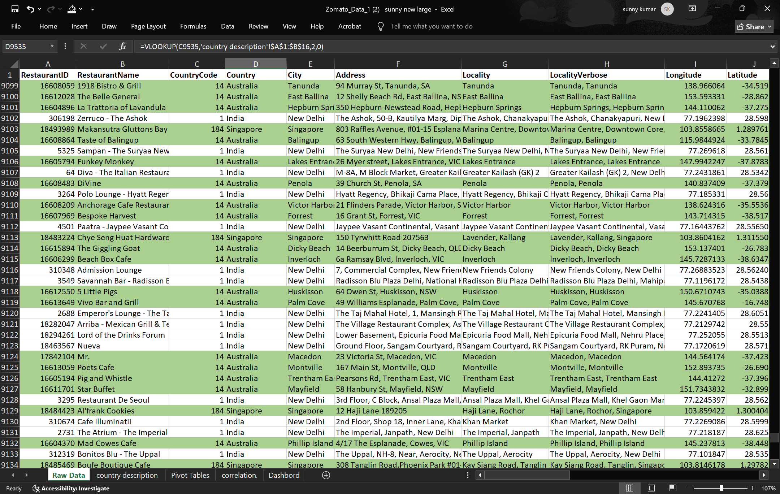

12.Create a new customized price column that consists of the abbreviation/symbol of the currency along with the Average_cost_for_two value. [Use string operations to do this task]

Ans
I initially created a manual list of the current currency symbols. Subsequently, I employed the VLOOKUP function along with the CONCATENATE function. This method enabled me to dynamically link each currency description to its corresponding symbol, thereby generating a customized column with the desired concatenated information.
Approach.
- First I created a new column. Column name N currency update .
- Then i extract symbol using formula like MID,FIND

Formula –
=MID(M2,FIND("(",M2)+1,FIND(")",M2)-FIND("(",M2)-1)
- After extracting the symbol I create a new column . column name V. average cost for two with symbol.
Location ; row data sheet -column V.
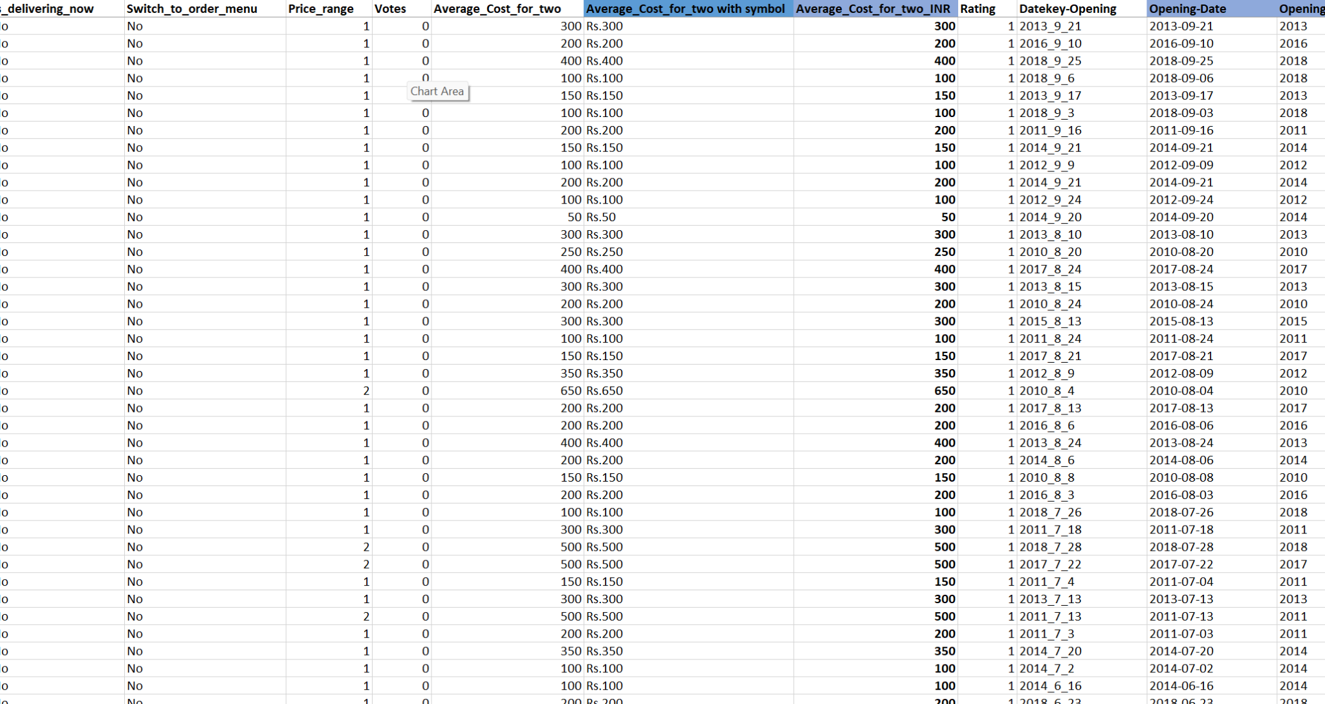

13.How can you create an array formula in Excel or Google Sheets to count the number of restaurants listed that do not offer online delivery, are in the lowest

ANS.
To solve this question, I converted the average cost for two, which is in different currencies for different countries, into rupees and then used the array formula.
{=SUM((P2:P9543="No") * (S2:S9543=1) * (T2:T9543<=250))}
=1694

After typing the formula, I press Ctrl + Shift + Enter to confirm it as an array formula.
Explanation of the Formula
· (P2:P9543="No"): Checks if the restaurant does not offer online delivery.
· (S2:S9543=1): Checks if the restaurant is in the lowest price range (assuming 1 indicates the lowest).
· (U2:U9543<=250): Checks if the average cost for two is less than or equal to 250.
· Multiplication: The multiplication * acts as a logical AND operator, meaning only rows that meet all conditions contribute 1 to the sum, while others contribute 0.
· SUM: The SUM function totals the counts of restaurants meeting all conditions.

Subjective Question:

1.Suggest a few countries where the team can open newer restaurants with lesser competition. Which visualization/technique will you use here to justify the suggestions?

Ans.
Approach
- I created pivot table from using the raw data
- I take country in rows
- And, count the restaurant ID in the value section
- Also, I found the average of the rating per country
- After doing all of the things, I suggest those countries whose average rating is between 3 and 4, and the number of the restaurants less than 30.
- Average of the rating >3 and average of rating <4
- Number of the restaurants <30
Reference.

country | COUNTA of RestaurantName | AVERAGE of Rating
United States of America | 434 | 4.011290323
United Kingdom | 80 | 4.1
United Arab Emirates | 60 | 4.233333333
Turkey | 34 | 4.3
Sri Lanka | 20 | 3.87
South Africa | 60 | 4.21
Singapore | 20 | 3.575
Qatar | 20 | 4.06
Philippines | 22 | 4.468181818
New Zealand | 40 | 4.2625
Indonesia | 21 | 4.295238095
India | 8652 | 2.770550162
Canada | 4 | 3.575
Brazil | 60 | 3.846666667
Australia | 24 | 3.658333333
Grand Total | 9551 | 2.89126793

Countries like canada ,sri lanka ,australia, singapore
These countries have less restaurants compared to others, so we can open new outlets in these countries .

Insights.
- Some country have high avg rating so, these are very high competitor restaurants
- When we see the table some country like canada,sri lanka ,australia ,singapore have average rating is under 4 and less number of restaurant so, these countries are not good for open new restaurant
.

Recommendation
- Zomato can targetcanada,sri lanka ,australia ,singapore . These countries have under 4 ratings and low amount of restaurants, so Zomato can open new outlets in these countries.

2. Come up with the names of States and cities in the suggested countries suitable for opening restaurants.

Approach.

- I created a pivot table from using the raw data
- Take country and city in rows and count the number of the restaurant and average rating in values.
- Avg rating of per cities.
- Filter the country we have suggested
- I suggest low number of restaurant city
- Average of the rating >3 and average of rating <4
- Number of the restaurants <30

Reference

Cities In The Suggested Countries
Row Labels | Count of RestaurantID | Average of Rating
Australia | 24 | 3.66
Armidale | 1 | 3.5
Balingup | 1 | 3.2
Flaxton | 1 | 3.5
Macedon | 1 | 3.5
Penola | 1 | 3.4
Canada | 4 | 3.58
Consort | 1 | 3
Yorkton | 1 | 3.3
Singapore | 20 | 3.58
Singapore | 20 | 3.575
Sri Lanka | 20 | 3.87
Colombo | 20 | 3.87

Insights.
- When we see some cities like Armidale,Flaxton,Macedon,Penola ,Colombo,Singapore etc these are low number of restaurant cities.

Recommendation
- When we see the chart, some cities have the most rating and low number of restaurants, so we can consider the cities for opening new restaurants .

3. According to the countries you suggested, what is the current quality regarding ratings for restaurants that are open there?
Ans .
Approach.
- I have to created a pivot table using the raw data
- Total number of restaurant of suggested country
- Avg rating suggested country
- Filter the country we have to suggested

Reference.

Row Labels | Average of Rating | Count of RestaurantID
Sri Lanka | 3.87 | 20
Australia | 3.658333333 | 24
Singapore | 3.575 | 20
Canada | 3.575 | 4
Grand Total | 3.691176471 | 68

Insights.
- When we see the table the selected countries are Sri Lanka , Australia,
Singapore,Canada

- These countries have good ratings .
- These countries have good ratings and the number of restaurants is low, so the team can open new restaurants in these countries.

Recommendation .
- We have genuinely considered opening a new restaurant because it is very very good.
- The country have good potential to growth speedly opening restaurants

4.Also, what is the current expenditure on food in the suggested countries, so we can keep our financial expenditure in control?

Approach

- I created pivot table
- Take suggested country in rows and sum of average cost for two in INR in value section
- Then i filtered my suggested country
- I created 3D column chart for visualisation

Reference.

Row Labels | Average of Average_Cost_for_two_INR
Australia | ₹ 1,999
Canada | ₹ 3,009
Singapore | ₹ 12,927
Sri Lanka | ₹ 641
Grand Total | ₹ 4,873

1.Average of the average cost for two in INR

Insights .
- When we look at the data the country name Singapore is more than 12000
- And , the Australia is near 2000, And , also the country name Canada is more than 3000
- The country name Sri Lanka is very low

Recommendation .
- The expenditure of the country name Singapore is very high so we have to control expenditure
- And , others have low expenditure this is good

5. Come up with the names of restaurants from the recommended states that are our biggest competitors and also those that are rated in the lower brackets, i.e. 1-2 or 2-3.

Approach.
- I created four pivot tables using the raw data .
- I take country in rows and restaurant name in rows section
- Then i filtered the suggested country like sri lanka ,canada , singapore , australia
- Also , i take rating and average cost for two in INR in value section
- I calculated average of the rating and Avg of the average cost for two in INR
- Then i choose some colour for highlight the restaurants
- I choose three different different colour for the restaurants name and rating

Reference.
Singapore - Competitor Analysis
Row Labels | Average of Rating | Average of Average_Cost_for_two_INR
Singapore | 3.575 | 12927.25
Al'frank Cookies | 4.2 | 1660
Fratini La Trattoria | 4.1 | 8300
Cut By Wolfgang Puck | 4 | 22410
Summer Pavilion | 3.9 | 24900
Rhubarb Le Restaurant | 3.9 | 26145
Bitters & Love | 3.9 | 3320
Jaan | 3.8 | 35690
Colony | 3.8 | 18260
Restaurant Andre | 3.8 | 41500
Artistry | 3.8 | 4150
Chye Seng Huat Hardware | 3.7 | 3320
Sky On 57 | 3.4 | 24900
Super Loco | 3.2 | 7885
The Refinery Singapore | 3.2 | 6640
Boufe Boutique Cafe | 3.2 | 4150
Artichoke Cafe | 3.2 | 6225
I Am | 3.2 | 4980
Potato Head Folk | 3.1 | 6640
The Lokal | 3.1 | 4980
Makansutra Gluttons Bay | 3 | 2490
Grand Total | 3.575 | 12927.25

Australia - Competitor Analysis
Row Labels | Sum of Rating | Sum of Average_Cost_for_two_INR
Australia | 87.8 | 47974
Bridge Road Brewers | 4.6 | 1660
1918 Bistro & Grill | 4.4 | 2490
Vivo Bar and Grill | 4.4 | 2490
Pig and Whistle | 4.1 | 1660
The Belle General | 4.1 | 1660
5 Little Pigs | 4.1 | 1660
Blue Bean Love Cafe | 3.8 | 1660
La Trattoria of Lavandula | 3.8 | 581
Three Anchors | 3.8 | 2490
Funkey Monkey | 3.8 | 581
Bespoke Harvest | 3.7 | 1660
Beach Box Cafe | 3.7 | 581
Mad Cowes Cafe | 3.7 | 1660
Anchorage Cafe Restaurant Wine Bar | 3.6 | 1660
The Giggling Goat | 3.6 | 581
Stillwater on Belmore | 3.6 | 1660
Whitebull Hotel | 3.5 | 1660
Flaxton Gardens | 3.5 | 2490
Mr. | 3.5 | 1660
DiVine | 3.4 | 1660
Taste of Balingup | 3.2 | 1660
Star Buffet | 2.9 | 1660
Pier 70 | 2.6 | 9960
Poets Cafe | 2.4 | 2490
Grand Total | 87.8 | 47974

Canada - Competitor Analysis
Row Labels | Average of Rating | Average of Average_Cost_for_two_INR
Canada | 3.575 | 3008.75
Lake House Restaurant | 4.3 | 5810
Tokyo Sushi | 3.7 | 2075
Arigato Sushi | 3.3 | 2075
Consort Restaurant | 3 | 2075
Grand Total | 3.575 | 3008.75

Sri Lanka - Competitor Analysis
Row Labels | Average of Rating | Average of Average_Cost_for_two_INR
Sri Lanka | 3.87 | 641.25
Ministry of Crab | 4.9 | 1080
Simply Strawberries By Jagro | 4.5 | 351
The Sizzle | 4.2 | 810
Butter Boutique | 4.2 | 270
Cricket Club Cafe | 4.2 | 810
Arabian Knights | 4.2 | 648
Burger's King | 4.1 | 270
Carnival Ice Cream | 4.1 | 270
Cafe Beverly | 4.1 | 540
The Commons | 4 | 675
T.G.I. Friday's | 4 | 1080
The Manhattan FISH MARKET | 4 | 1215
Upali's | 4 | 675
Cafe Shaze | 3.8 | 945
CIOCONAT Lounge | 3.7 | 675
The Paddington | 3.6 | 540
Malay Restaurant | 3.5 | 405
Chinese Dragon Cafe | 3.4 | 540
Queen's Cafe | 2.5 | 540
Elite Indian Restaurant | 2.4 | 486
Grand Total | 3.87 | 641.25

Insights.

- When we look at the data the rating of the restaurants is high so, I use green colour for highlight high rating restaurants and i use orange colour for lower barackets rating restaurants.

- Restaurants that are biggest competitors: When we see Green colour data these are high rating restaurants so , these are biggest competitors

Recommendation
- Orange colour marked restaurants is average rating restaurants so these are
Best for opening new restaurants

6.Which cuisines should we focus on in the newer restaurants to get better feedback? Does the choice of cuisines affect the restaurant ratings?

Ans.
Approach.
- I create pivot table
- I take country and cuisines in rows and average of rating in value field
- Then i filtered the suggested country
- And , also filtered the maximum rating
- I finded the maximum avg of rating for each cuisines
Reference .

Top performed cuisines
Row Labels | Average of Rating
Australia | 4
Australian | 4.1
Breakfast, Modern Australian | 4.1
Cafe | 4.1
Mediterranean, Seafood | 4.4
Modern Australian, Australian | 4.4
Pizza, Bar Food | 4.6
Canada | 4.3
Italian, Mediterranean, Pizza | 4.3
Singapore | 4
Bakery | 4.2
Italian | 4.1
Sri Lanka | 4
American, Fast Food, Steak, Beverages | 4.2
Continental, American | 4.1
Continental, American, Seafood | 4.2
Desserts, Bakery | 4.2
Desserts, Ice Cream | 4.1
Fast Food | 4.1
Juices, Desserts | 4.5
Middle Eastern, Arabian | 4.2
Seafood | 4.9
Grand Total | 4

Low performed cuisines
Row Labels | Average of Rating
Australia | 3
Asian | 2.9
Coffee and Tea, Modern Australian | 2.4
Modern Australian | 2.6
Canada | 3
Chinese, Canadian | 3
Singapore | 3
American | 3.1
Singaporean, Australian, German | 3.1
Singaporean, Chinese, Seafood, Malay, Indian | 3
Sri Lanka | 2
American, Chinese, North Indian | 2.5
North Indian, Chinese, Sri Lankan | 2.4
Grand Total | 3

Insights.
- Yes, cuisine type does affect customer ratings.
- Pizza, Bar Food,Modern Australian, Australian , Mediterranean, Seafood,Juices, Desserts,Continental, American, Seafood,Italian , Bakery etc consistently receive higher
ratings.
- These cuisines are popular, familiar, and often associated with better service and food quality.

Recommendation .
- CUISINES TO FOCUS - Pizza, Italian, Seafood, Mediterranean, Modern Australian, Bakery, Desert, American, Chinese.
- Zomato can target these cuisines for better feedback and high ratings.

7.According to our current data, should we go for online delivery and table booking? Does that affect the customer’s ratings?
Ans.
We analyzed the dataset using AVERAGEIFS formulas in Excel to calculate the average ratings for:
- Restaurants that provide online delivery vs. those that do not
- Restaurants that offer table booking vs. those that do not
Reference .
- For Online Delivery:
=AVERAGEIFS(S2:S9552, M2:M9552, "Yes") → Rating with online delivery
=AVERAGEIFS(S2:S9552, M2:M9552, "No") → Rating without online delivery

- For Table Booking:
=AVERAGEIFS(S2:S9552, N2:N9552, "Yes") → Rating with table booking
=AVERAGEIFS(S2:S9552, N2:N9552, "No") → Rating without table booking

Feature | Avg. Rating (Yes) | Avg. Rating (No)
Online Delivery | 3.8 | 3.2
Table Booking | 3.9 | 3.5
observation .

- Online delivery improves ratings
- Table booking also boosts satisfaction
insights .
- Yes, the data shows that restaurants offering online delivery and table booking consistently receive higher ratings.
- These features are important for customer convenience, which leads to better experiences and more positive feedback.
Recommendation
- Zomato should enable both online delivery and table booking in its new restaurant launches to improve customer ratings and satisfaction.

8.Should the team keep the rate of cuisines higher? Will that affect the feedback? According to our data are the rates of cuisines and ratings, correlated?

Approach.

- I have used the function to find the correlation between the rate of cuisines and ratings
- Formula:=CORREL(A2:A69,B2:B69)

Reference .

Correlation Between Rate Of Cuisines And Rating
CORRELATION | -0.003513202

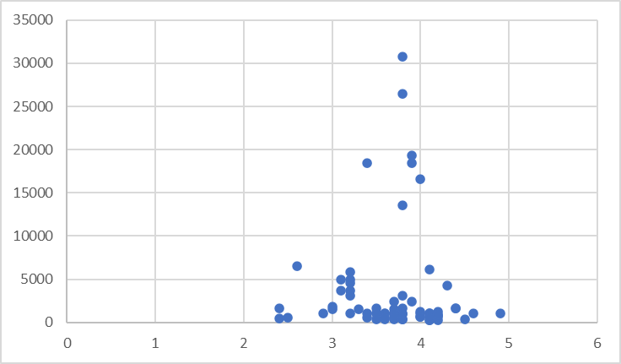

Insights
- ● Sign (-): The negative sign indicates a slight negative correlation. This means that as restaurant ratings increase, there is a very small tendency for the cost for two to decrease slightly, and vice versa. However, the correlation is so close to zero that it's essentially negligible.
- ● Magnitude (Absolute Value): The absolute value (ignoring the negative sign) is very close to zero (0.0057), indicating an extremely weak correlation. In practical terms, the correlation is so minimal that it's unlikely to be practically significant.

Recommendation .
● We can keep the rate of cuisines higher, as the correlation between rating and rate of cuisines is very negligible.

● Location: Excel File - sheet name Correlation

9.What is the distribution of the number of restaurants of different price ranges in all the countries?
Ans .
Approach.
- I created a pivot table for analyzing the trends
- I take country name in rows
- I take price range in column and count the number of the restaurant in value

Reference .

COUNTA of RestaurantID | Price_range
country | 1 | 2 | 3 | 4 | Grand Total
Australia | 4 | 14 | 5 | 1 | 24
Brazil | 2 | 7 | 16 | 35 | 60
Canada |  | 3 |  | 1 | 4
India | 4295 | 2858 | 1111 | 388 | 8652
Indonesia |  | 1 | 20 |  | 21
New Zealand | 3 | 4 | 17 | 16 | 40
Philippines |  | 1 | 12 | 9 | 22
Qatar |  | 1 | 5 | 14 | 20
Singapore |  | 1 | 5 | 14 | 20
South Africa |  | 4 | 17 | 39 | 60
Sri Lanka |  | 6 | 11 | 3 | 20
Turkey |  | 11 | 18 | 5 | 34
United Arab Emirates |  | 9 | 29 | 22 | 60
United Kingdom | 4 | 28 | 32 | 16 | 80
United States of America | 136 | 165 | 110 | 23 | 434
Grand Total | 4444 | 3113 | 1408 | 586 | 9551

Insights.
- The data show that India has a large number of low-budget restaurants (Price Range 1), showing that affordability is a key factor.
- Total number of restaurant price range 1 is 4444
- Total number of restaurant price range 2 is 3113.
- Total number of restaurant price rage 3 is 1408
- Total number of restaurant price range 4 is 586

Recommendation
- In India and UK, focus on launching affordable restaurants (Price 1 or 2)
- In UAE and South Africa, consider a mix of budget and premium options based on customer segments.
10.Explain your approach in brief for suggesting countries/cities in order to open new restaurants, if the objective and subjective questions would have not been given to assist you. [you have to give bullet pointers in order to answer this question]

countries Suggested (Sri lanka,Australia , Canada, Singapore):

- Analytical Criteria:
- Utilized Pivot tables with restaurant count and average ratings.
- Applied filters for low competition and ratings between 3 and 4
- Strategic Insights:
- Identified regions with both low competition and potential for improvement in average ratings.
- Focused on countries where market entry could yield substantial benefits.

- City Selection:

- Analytical Criteria:
- Employed a similar Pivot table approach on city-level data.
- Focused on cities within suggested countries with low competition and ratings between 3 and 4
- Strategic Insights:
- Choose cities aligning with the overall country criteria.
- Aimed for a balanced selection of cities within the recommended countries based on data analysis.
- The dashboard must consist of Year-wise and country slicers.

